**Membership Monthly Tracking and Trending**



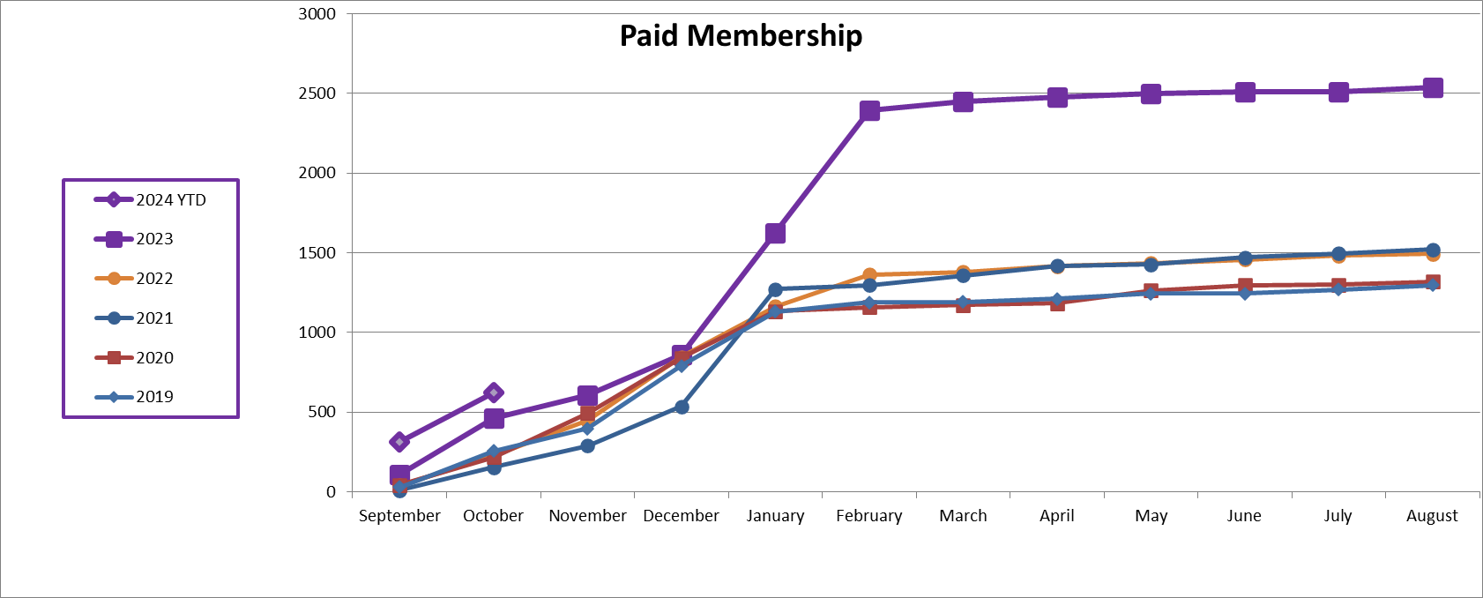

**Membership Numbers to Budget:**



**Paid Community Regional Breakdown:**



**2024-2028 European Strategy Update**



**2024 Membership Type Analysis**



*Note that the 2024 Early Career number is trending high due to the Buy One-Get One promotion in 2023.